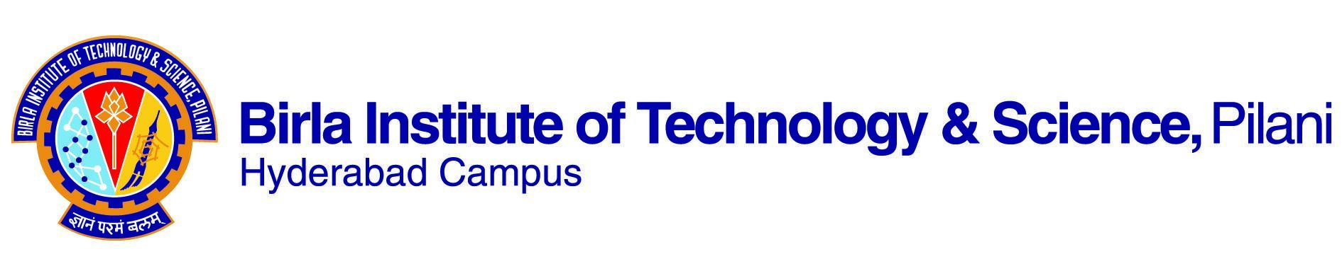

**FIRST SEMESTER 2023-2024**

# Course Handout Part II

Date: 11.08.2023

In addition to Part-I (General Handout for all courses appended to the time table) this portion gives further specific details regarding the course.

*Course No.* : BITS F452

## Course Title : Blockchain Technology

## Instructor-in-Charge : Prof. G Geethakumari

**1.Scope and Objectives of the course**

Blockchains are tamper evident and tamper resistant digital ledgers implemented in a distributed fashion (i.e., without a central repository) and usually without a central authority. The recent developments in Blockchain Technology have led to its pervasive influence in both economic as well as non-economic transactions. This course aims to provide a comprehensive understanding of the essential concepts involved in blockchain technology and its applications. The scope of the course is to give the students a fundamental understanding of the blockchain architecture, cryptocurrencies (especially Bitcoin), Smart contracts, Consensus algorithms, as well as Permission less and Permissioned blockchains. The development of Decentralized Applications using Ethereum and Hyperledger would give the students the required hands-on experience of the blockchain concepts. The case studies, the discussions and the projects would enable the students to assimilate the concepts better.

The objectives of the course are:

* To provide a comprehensive understanding of the foundational and other essential concepts involved in blockchain technology.
* To introduce the features and development process of decentralized applications pertaining to a number of verticals such as finance, supply chain, governance etc. through theory and practice
* To introduce the current advancements in the Blockchain Technology and a few topics beyond blockchains such as DAG-based distributed ledgers.

**2.Text Book**

TB: Imran Bashir, Mastering Blockchain: Distributed ledger technology, decentralization, and smart contracts explained, 2nd Edition, Packt Publishing, 2018.

**3.Reference Books**

R1: Narayanan, Arvind, Joseph Bonneau, Edward Felten, Andrew Miller, and Steven Goldfeder. Bitcoin and cryptocurrency technologies: a comprehensive introduction. Princeton University Press, 2016

R2. The Book of Satoshi: The Collected Writings of Bitcoin Creator Satoshi Nakamoto' Champagne (2014) ISBN: 9780996061315

R3..Bitcoin and Cryptocurrency Technologies: A Comprehensive Introduction' Narayanan, Bonneau, Felton, Miller & Goldfeder (2016) ISBN: 9780691171692

R4. Mastering Bitcoin: Programming the Open Blockchain' Antonopoulos (2017) ISBN: 9781491954386.

R5. The Internet of Money (1-3 Volumes): Andreas M. Antonopoulos

**4.Online Resources:**

(i) MIT Open Courseware on Blockchain Technology

(ii)  <https://bitcoinmagazine.com/>

**5. Course Plan:**

|  |  |  |  |
| --- | --- | --- | --- |
| **Lecture**  **No.** | **Learning Objectives** | **Topics to be covered** | **Chapter in the Text Book** |
| 1-5 | To get an overview of Blockchain Technology | Defining Blockchain and Distributed Ledger, Blockchain Properties: Decentralized, Transparent, Immutable and secure.  Blockchain Applications. Types of Blockchain: Public, private, and consortium based blockchain, When to use, and when not to use Blockchain, History of Blockchain. | TB: Ch 1  R1: Ch 0,1 |
| 6-8 | To get introduced to computing models and P2P networking | Centralized, Decentralized and Distributed Systems, Decentralization vs distributed, P2P systems, properties of P2P systems, P2P communication architecture. P2P network  applications: File sharing, P2P network for blockchain | TB: Ch 1 |
| 9-12 | To understand the foundational concepts and Blockchain Data Structure | Cryptographic Hash Functions, Digital Signatures, Public Keys as Identities, Hash Pointers and Hash chain and Merkel tree, Consensus mechanisms | TB: Ch3 R1: Ch1 |
| 13-18 | To learn about the Blockchain Characteristics | Decentralized Identity management, Transactions, incentivizing and mining. Distributed Consensus (PoW), Cryptocurrency as the first blockchain application. Mechanics of Bitcoin, Bitcoin Scripts, Storing and Using Bitcoins, Mining in Bitcoin. | TB: Ch4  R1: Ch 2,3,4,5,6  R2, R3 |
| 19-21 | To understand other Consensus Mechanisms | Proof of storage, proof of stake**,** proof of deposit, proof of burn, proof of activity. algorithms for adjusting difficulty and  retargeting. Limitations of Bitcoin, alternative cryptocurrencies. | TB: Ch5 R1: Ch 8  R4, R5 |
| 22-27 | To know about Smart Contracts and Ethereum | History, Purpose and types of smart contracts, Introduction to Ethereum, bitcoin vs Ethereum stack. P2P network in Ethereum, consensus in Ethereum, scripts in Ethereum, Smart contracts (Ethereum Virtual Machine). Developing and executing smart contracts in Ethereum. State and data structure in Ethereum. | TB: Ch 6, 7,8  R1: Ch 11 |
| 28-33 | To understand Private and Consortium based Blockchain: Hyperledger | Need for consortium. Hyperledger stack, Multichain blockchain. Innovation in Hyperledger, smart contracts, and distributed applications in hyperledger. | TB: Ch 9 |
| 34-40 | To explore Case studies/ Enabling  Technologies and applications | Application of blockchain in privacy and security, IoT and smart cities, Business and Industry, Data management, e-Governance | TB: Ch 10,11 R1: Ch11 |

**6.Evaluation Scheme:**

|  |  |  |  |  |
| --- | --- | --- | --- | --- |
| **Component** | **Duration** | **Weightage (%)** | **Date & Time** | **Nature of Component** |
| Mid Sem Test | 90 min | 30% | 14/10 - 4.00 - 5.30PM | Closed Book |
| Quizzes (2 nos.)  *(Evenly spaced out – 5% to be completed before mid sem)* |  | 10% |  | Closed Book |
| Term Project  *(evaluation at different milestones-5% to be completed before mid sem)* |  | 20% |  | Open Book |
| Comprehensive Exam | 3 hours | 40% | 21/12 AN | Closed Book |

***Note: 40% of the evaluation to be completed by midsem grading.***

**7.Chamber Consultation Hour:** To be announced in the class

**8.Notices:** The notices for this course would be put up in CMS.

**9.Make-up Policy:** No makeup exam allowed without prior permission.

**10.Academic Honesty and Integrity Policy:** Academic honesty and integrity are to be maintained by all the students throughout the semester and no type of academic dishonesty is acceptable.

**INSTRUCTOR-IN-CHARGE**

**BITS F452**